**ACT**



Mata Praktikum : ORACLE INTERMEDIET

Kelas : 3IA20

Praktikum ke- : 7

Tanggal : 13 November 2022

Materi :

NPM : 50420900

Nama : Muhammad Reza Hidayat

Ketua Asisten :

Nama Asisten :

Paraf Asisten :

Jumlah Lembar :



**LABORATORIUM TEKNIK INFORMATIKA**

**UNIVERSITAS GUNADARMA**

**2022**

**ACT**

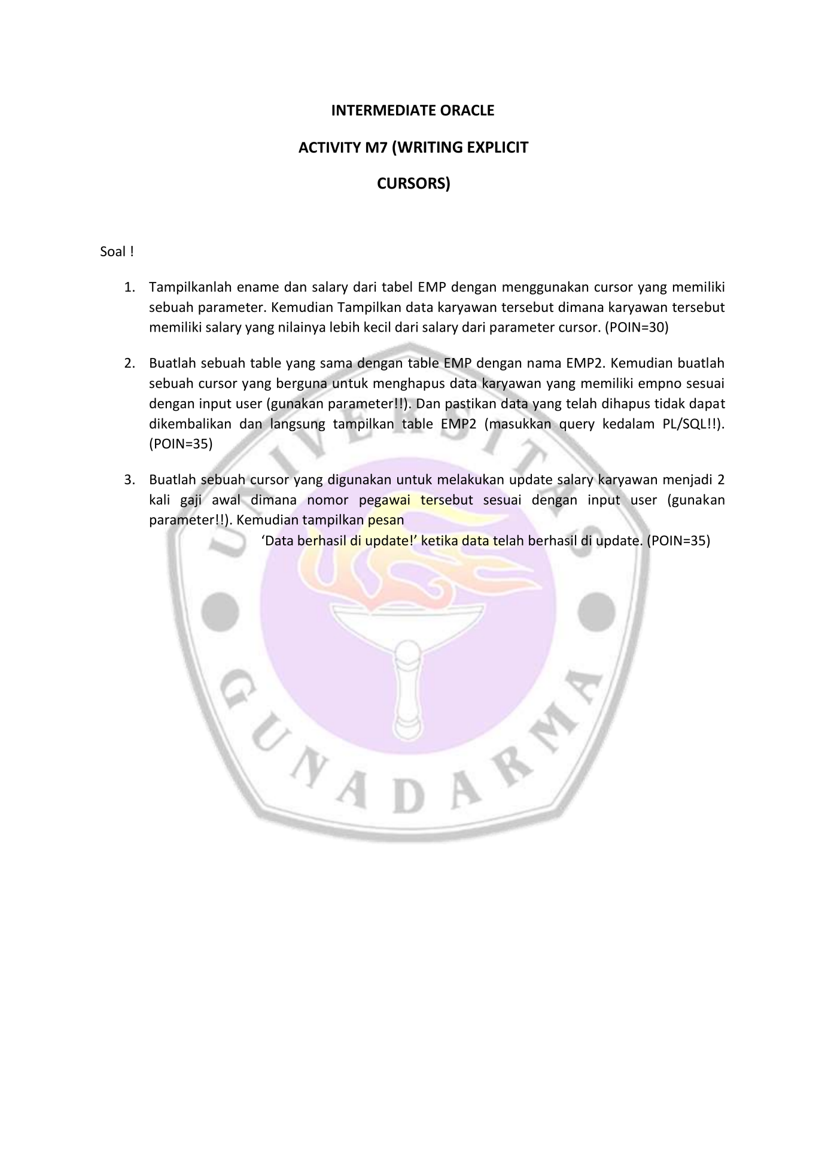

1. LISTING PROGRAM

SET serveroutput ON

declare

cursor cur_emp(sal_param number) is

select ename, sal

from emp

where sal > sal_param

order by sal desc;

namaku emp.ename%type;

gajiku emp.sal%type;

begin

open cur_emp(2501);

loop

fetch cur_emp into namaku, gajiku;

exit when cur_emp%notfound;

dbms_output.put_line(namaku||'memiliki gaji :'||gajiku);

end loop;

close cur_emp;

end;

/

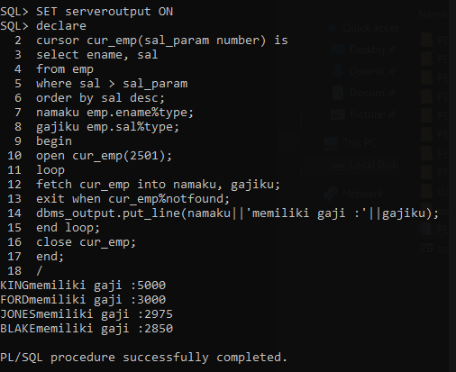

--2

declare

cursor cur_emp_del(emp_id varchar2) is

select empno

from emp

where empno = emp_id

for update;

id emp.empno%type;

begin

open cur_emp_del('7788');

fetch cur_emp_del into id;

if cur_emp_del%found then

delete from emp

where current of cur_emp_del;

dbms_output.put_line('emphidayat');

dbms_output.put_line('data sukses dihapus');

commit;

else

dbms_output.put_line('data not found');

end if;

close cur_emp_del;

end;

/

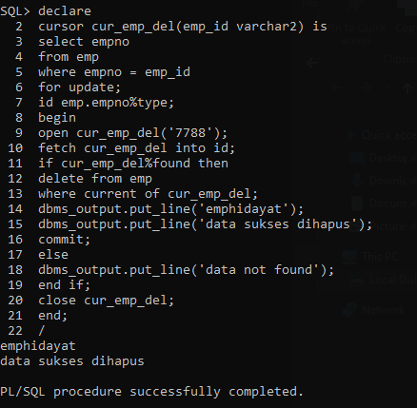

select * from emp;

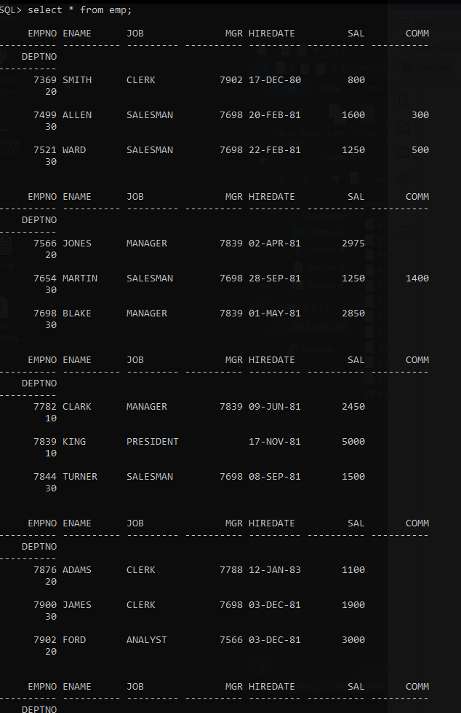

SET serveroutput ON

declare

cursor cur_emp_update(comp_emp_id number) is

select sal from emp

where empno = comp_emp_id

for update of sal;

id emp.empno%type;

begin

open cur_emp_update(7900);

fetch cur_emp_update into id;

if sql%notfound then

dbms_output.put_line('karyawan tidak di temukan');

else

update emp

set sal = sal * 2

where current of cur_emp_update;

dbms_output.put_line('berhasil di update');

end if;

close cur_emp_update;

end;

/

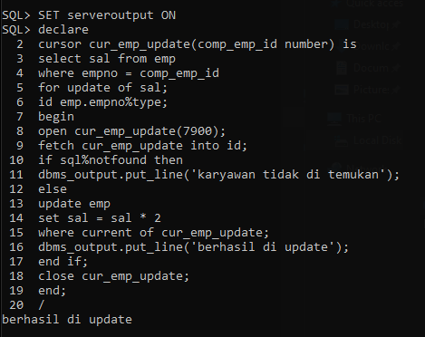

select * from emp;

